- To download MySQL installer, copy the below link on your browser and press Enter
https://dev.mysql.com/downloads/file/?id=510039
The below page opens showing the Login Now or Sign Up for a free account. Simply click on No thanks, just start my download as shown below.
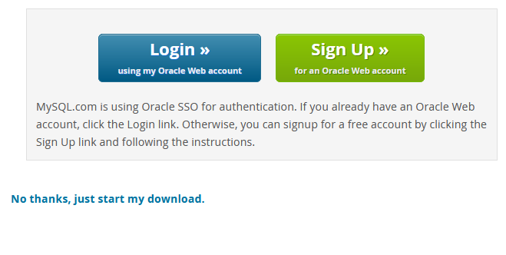
- To install MySQL using the MySQL installer, double-click on the MySQL installer you downloaded and follow the steps mentioned below:
Step 1: Windows configures MySQL Installer.
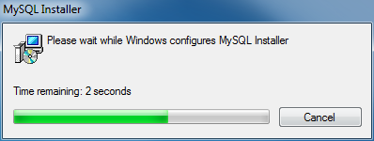
Step 2: Microsoft Visual C++ Redistributable dialog may appear for some to have it installed. Click the check box to accept the license agreement. Click Install or else you can proceed to next step.
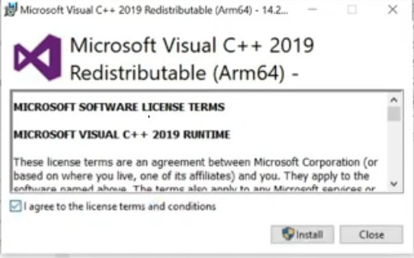
Step 3: In the next wizard, you have to choose the setup type. Basically, this is where you choose which features you wish to install. Here I will choose the option Full and click on Next.
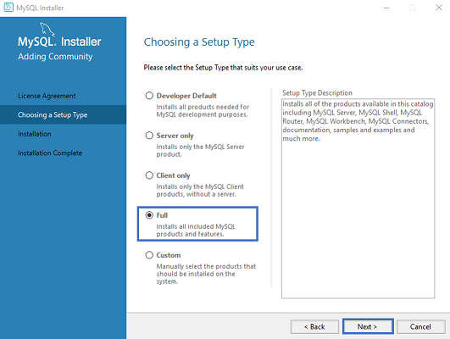
This option will MySQL Server, MySQL Shell, MySQL Router, MySQL Workbench, MySQL Connectors, documentation, samples and examples and much more.

{OPTIONAL STEP(If prompted for:
Upon execution of the previous step, the installer grasps all recommended products in place and asking for our approval to execute the product installation process. Click on Execute.}
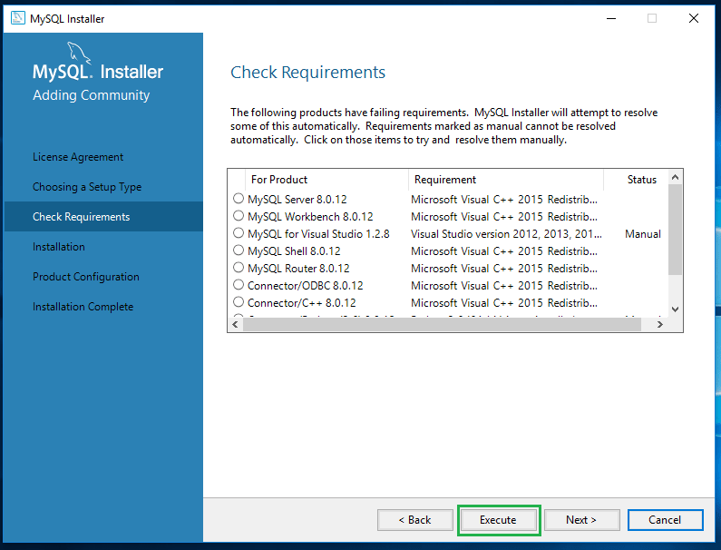

Step 4: Once you click on Next, you might see that some features may fail to install due to lack of requirements. So, either you can resolve them, or can skip them, by clicking on Next. Here I will click on Next.
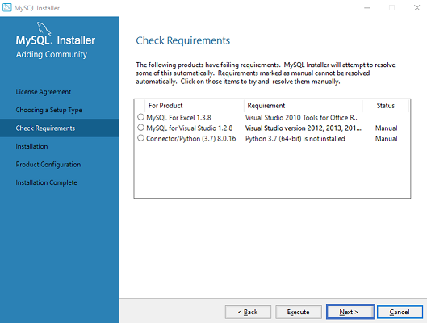

Step 4.1: Next, you will see a dialog box asking for your confirmation of a few products not getting installed. So, you can just click on Yes. Refer below.
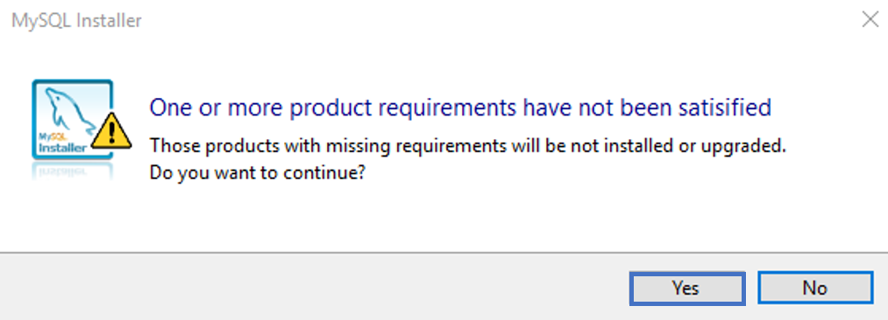

As soon as you click on Next, you will see the list of the products which will get installed. So, if you are fine with the products, go ahead and click on Execute as below.
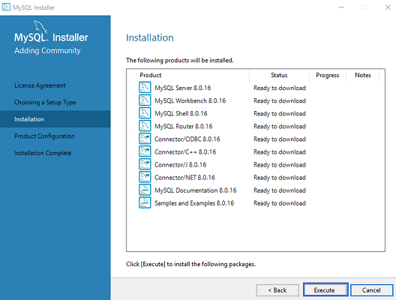
Once you hit on Execute, you will see that the products are getting installed. Refer below: Now, once the installation is complete, click on Next.
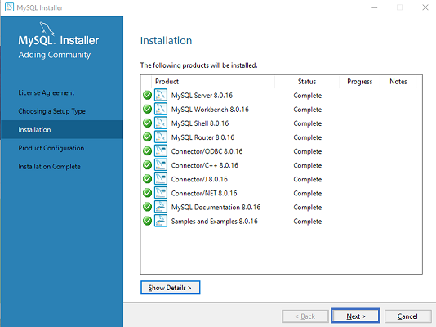

Server Configuration
Next, you have to configure the Server and Router. Well, over here let me tell you that, I am not going to configure the Router now since it is not required to simply use MySQL. But I will show you how to configure Server. So, in the below dialog box, click on Next.
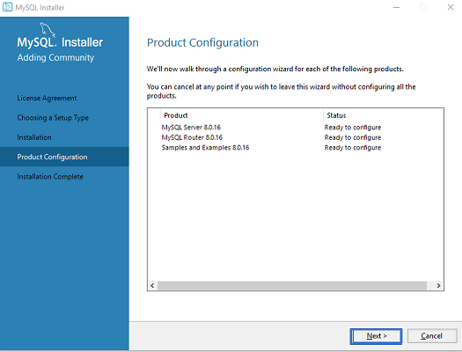

Step 5: In the below wizard, we will choose, Standalone MySQL Cluster and then click on Next.
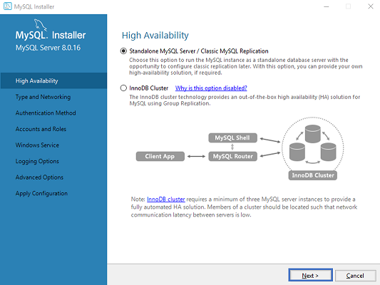
Step 6: Once, you click on Next, you have to mention the server configuration. So, we will leave it as it is and then click on Next.
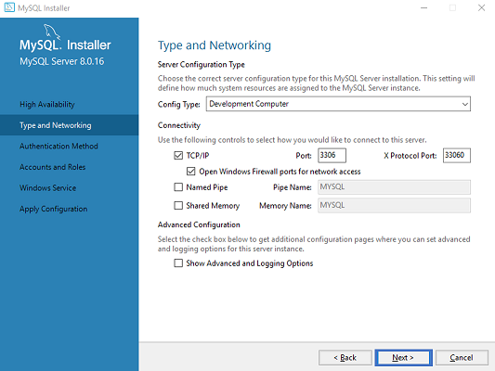

Step 7: Now, you have to choose the authentication method. Here, we will choose the first option and click on Next. Refer below.
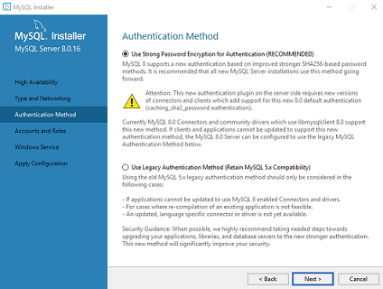
Step 8: Next, we have to mention the MySQL Root Password and again click on Next.
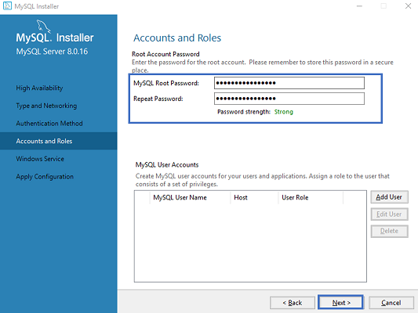
NOTE: Please provide password as root.

Step 9: Finally, you have to choose whether you want to start the server or not. Here, I am going to leave it as it is. Then, click on Next.
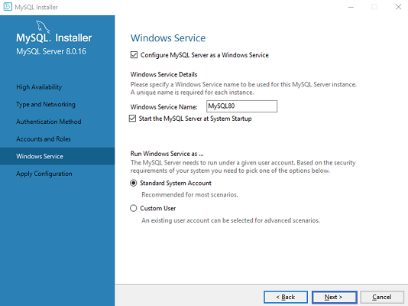
Now, the wizard will give you a list of the configurations which will be applied. So, we will agree with the configuration click on Execute.
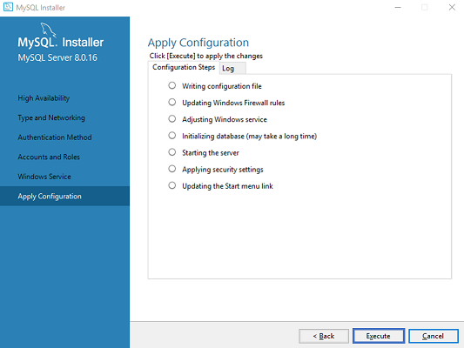

Once the execution is done, click on Finish. This will finish the configuration of Server.
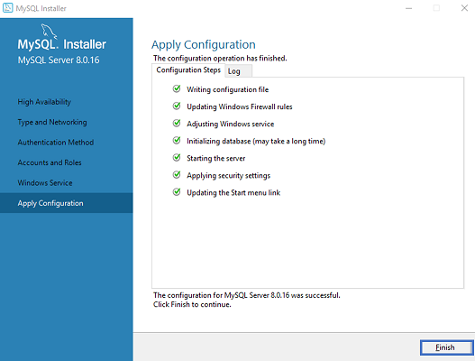
Step 10: In the next wizard that comes up, just click on Next and click on Finish.
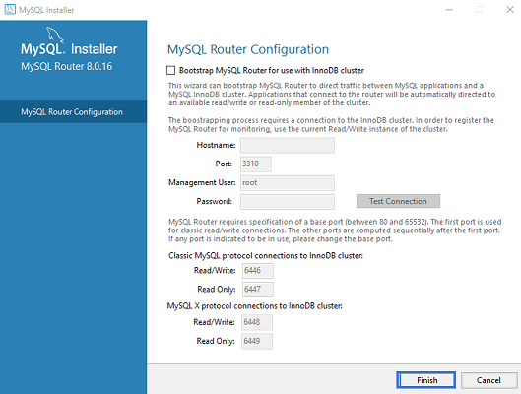

Step 11: Once, you click on Finish, you will see the following wizard, to Connect to server. Here mentions the root password, which you had set in the previous steps. Refer below.
.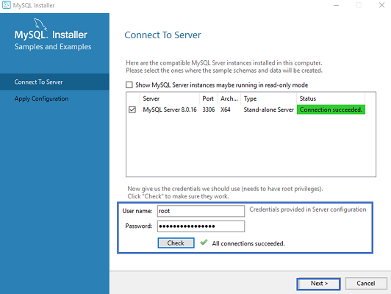
Check if the connection is successful, by clicking on the Check button and then click on Execute. Now, once the configuration is complete click on Next.
Step 12: Once, you click on Next, choose the configurations applied and click on Execute.
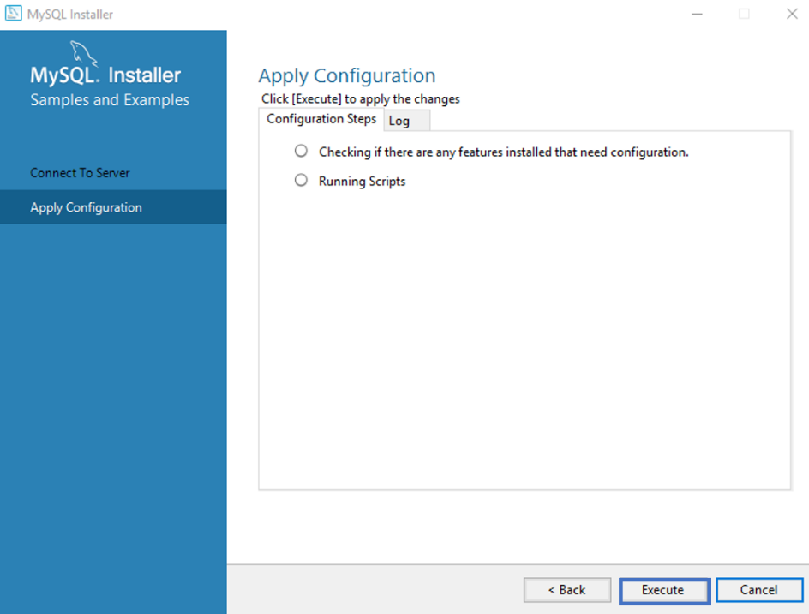
After the configurations get applied, you will see the following screen. So, here just click on Finish. Refer below.
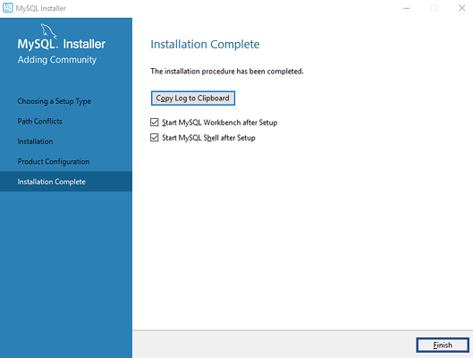
Step 13: After successful installation, MySQL Shell and MySQL workbench will appear.
